**Email Campaign Performance Dashboard**  
*Project Report by Vaibhav Sharma*  
*Date: May 16th, 2025*  
*Tools Used: Python, Pandas, Power BI, Excel*

**INDEX**

|  |  |
| --- | --- |
| **Section** | **Page No.** |
| **1. Project Overview** | **3** |
| **2. Objective & Goals** | **4** |
| **3. Dataset Description** | **5** |
| **4. Analysis & Key KPIs** | **6** |
| **5. KPI Dashboard (Visual Section)** | **7-12** |
| **6. Conclusion & Recommendations** | **13** |
| **7. Next Steps** | **14** |

**1. Project Overview**

This project analyses simulated email marketing campaign data to uncover performance trends, optimize KPIs (Key Performance Indicators), and visualize results through an interactive dashboard. The goal is to derive actionable insights that can help marketing teams improve campaign effectiveness and drive higher engagement and revenue.

**2. Objective & Goals**

* Analysed the effectiveness of different email campaigns.
* Track and compare KPIs such as open rate, click rate, conversion rate, and revenue.
* Identify top-performing and underperforming campaigns.
* Provide actionable recommendations to improve future campaign results.

**3. Dataset Description**

The dataset consists of 500 simulated entries representing email campaign performance. Each row corresponds to an individual email instance.

**Columns Included:**

* ***email_id***: Unique identifier for each email.
* ***campaign_id***: Identifier of the campaign the email belongs to (e.g., CAMPAIGN_1 to CAMPAIGN_5).
* ***send_date***: The date the email was sent.
* ***open_rate***: The percentage of recipients who opened the email.
* ***click_rate***: The percentage of opened emails where a link was clicked.
* ***unsubscribes***: Number of recipients who unsubscribed.
* ***conversion_rate***: Percentage of recipients who completed a desired action (purchase, sign-up, etc.).
* ***revenue_generated****:* Estimated revenue earned from the email.

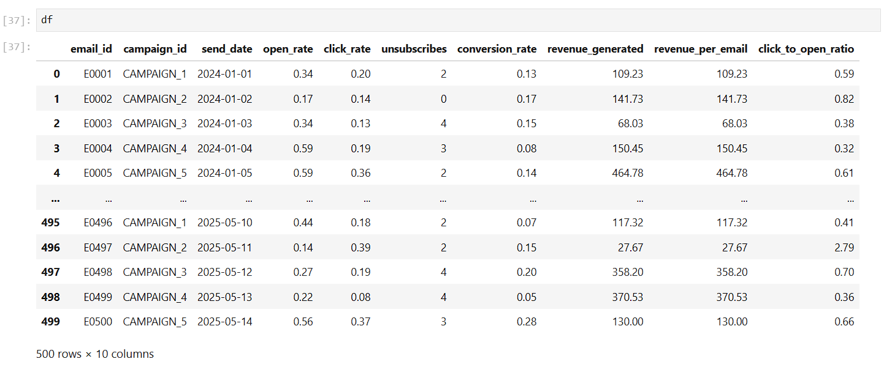

**4. Analysis & Key KPIs**

**KPIs Analyzed:**

* **Open Rate**: Engagement indicator measuring interest in subject lines.
* **Click Rate**: Indicator of how effective the email content and CTAs were.
* **Conversion Rate**: Measures how well the emails translated into meaningful actions.
* **Unsubscribe Count**: Helps determine if content is disengaging.
* **Revenue per Email**: Business-focused metric indicating ROI per email.

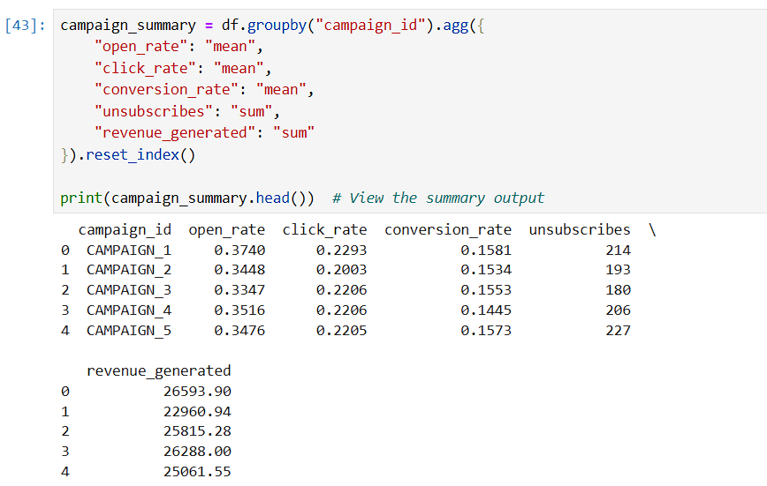

**5. KPI Dashboard (Visual Section)**

This visual represents the complete email campaign performance dashboard built using Power BI. It consolidates all key KPIs and campaign metrics into a single interactive view for quick insights and strategic decision-making.

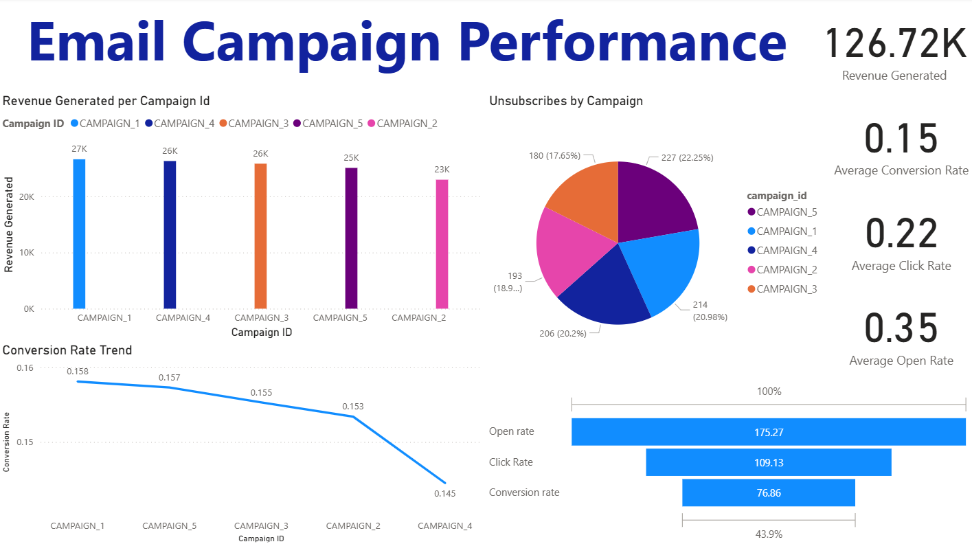

**Bar Chart – Revenue by Campaign**

This bar chart compares the total revenue generated by each email campaign.

Insight:

Campaign 1 significantly outperformed all others in terms of revenue, suggesting a highly successful strategy in its messaging or target segmentation. Campaigns 2 and 5 generated the least revenue, highlighting areas where marketing efforts may require revaluation.

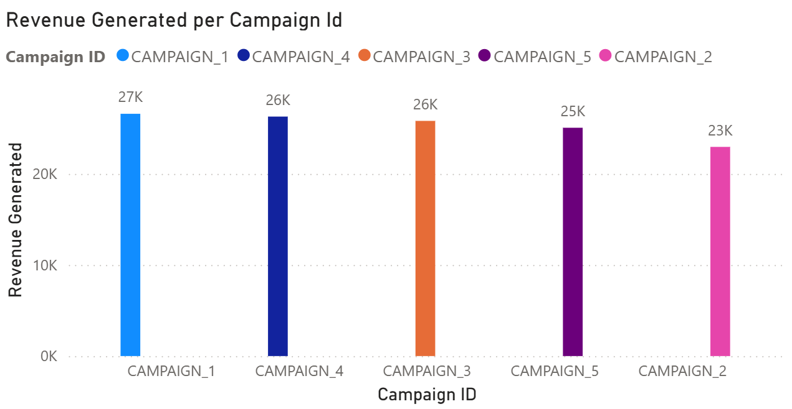

**Pie Chart – Unsubscribes by Campaign**

This pie chart represents the distribution of unsubscribe actions across different campaigns.

**Insight:**

Campaign 5 recorded the highest percentage of unsubscribes, which could indicate that its content did not align with user expectations or was sent too frequently. In contrast, Campaign 3 had the lowest unsubscribe rate, signalling better audience resonance.

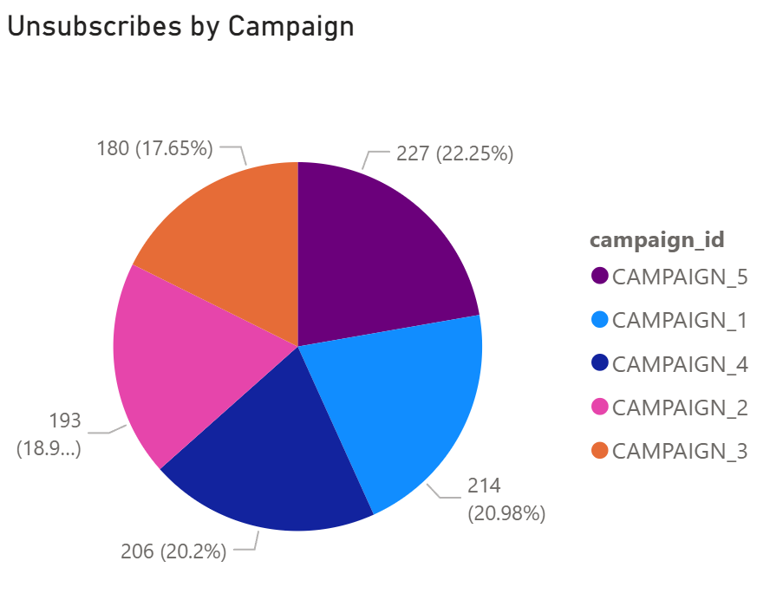

**KPI Cards – Average Open Rate, Click Rate, Conversion Rate, Revenue**

These key performance indicators provide an at-a-glance overview of campaign health.

**Insight:**

The average open rate is satisfactory, suggesting strong subject lines. Click rates align with industry benchmarks, but the conversion rate highlights an opportunity to strengthen calls-to-action and post-click experiences. The revenue figure offers a financial benchmark to assess ROI.

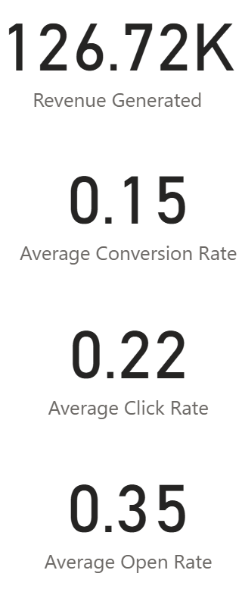

**Line Chart – Conversion Rate Over Time**

This line chart visualizes how the conversion rate fluctuated across different campaigns over time.

**Insight:**  
The trend indicates a gradual improvement in conversion rates up to Campaign 3, followed by a slight decline. This pattern may suggest that user engagement peaked mid-way and was not sustained due to possible content fatigue or less compelling offers in later campaigns.

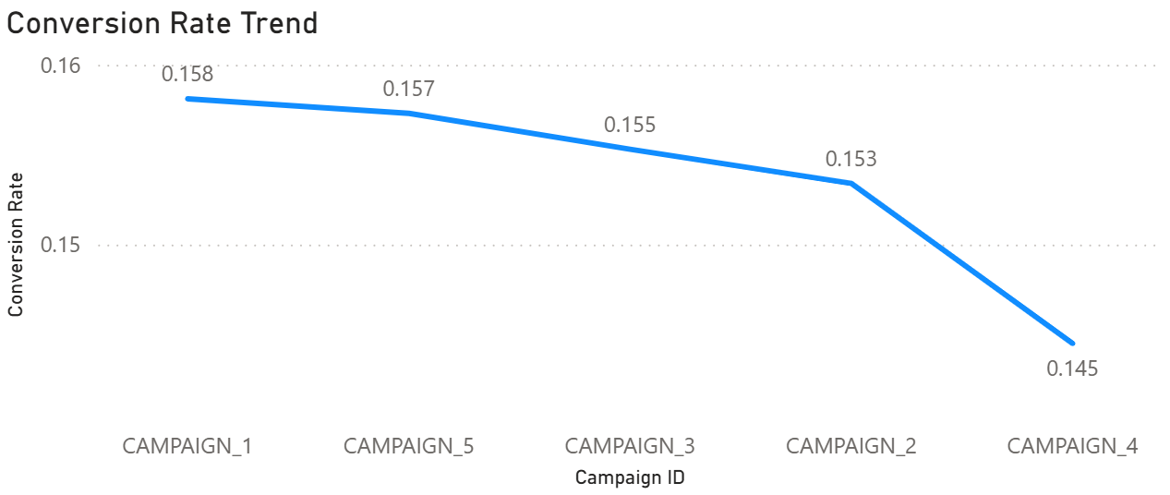

**Funnel Chart – Email to Conversion Flow**

This funnel chart tracks the user journey from email sent to final conversion.

**Insight:**  
A high open rate and a decent click-through rate show strong initial engagement. However, there is a noticeable drop between clicks and conversions, pointing to a potential issue in the landing page experience or purchase process that needs further optimization.

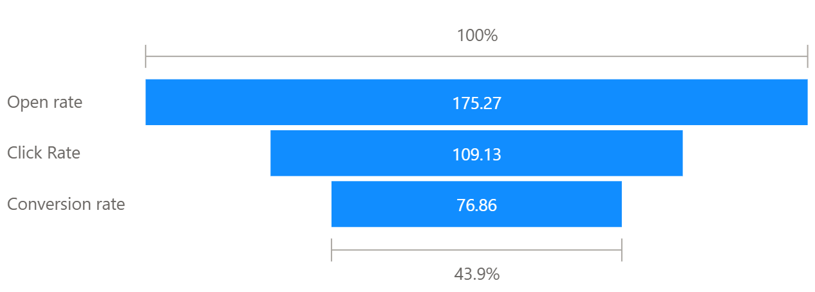

**6. Conclusion & Recommendations**

**Conclusion:**

The analysis demonstrates how various KPIs interact across different campaigns and what factors contribute to high-performing marketing strategies. Patterns in open rates, click-to-open ratios, and revenue generation provide key benchmarks.

**Recommendations:**

* Focus budget and creative efforts on high-performing campaigns like Campaign 3.
* Improve email subject lines and preview text for campaigns with low open rates.
* Test and refine CTAs and landing pages for campaigns with low conversion despite high clicks.
* Monitor unsubscribe trends to identify and resolve engagement drop-off issues.

**7. Next Steps**

* Share this report and dashboard with marketing stakeholders.
* Automate regular KPI reporting using Power BI service or Tableau Server.
* Extend analysis to include A/B testing results and user segmentation.

*End of Report*